Lab 4: ALU Operations
Learning Outcomes

- Students will learn about various flags and their purposes.
- Students will learn various arithmetic and logic operations.
- Students will be able to perform arithmetic operations and logic operations on n-bit numbers.
- Students will learn what instructions affect which flags.

Flag Register
The 8086 processor contains a 16-bit flag register where nine bits are used as flags as shown in the following figure. Out of which, 6 flags indicate the status of recently executed instruction, while the remaining 3 are control flags.
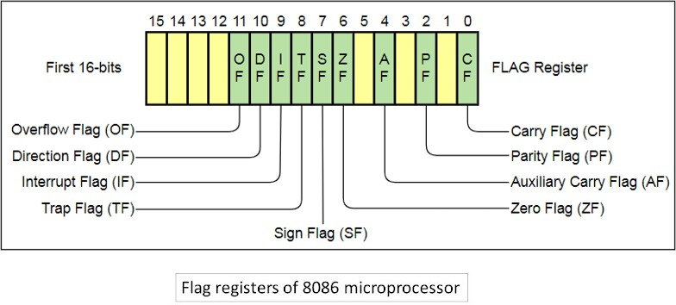

Status Flag Registers:
- Overflow Flag (OF):

The overflow Flag is set to 1 when there is a signed overflow. For example, when you add bytes 100 + 50 (result is not in range -128…127).

Example:

On adding bytes 100 + 50 (result is not in range -128…127), so overflow flag will set.
MOV AL, 100 (100 is 0110 0100 which is positive)
MOV BL, 50 (50 is 0011 0010 which is positive) ADD AL, BL (150 is 1001 0110 which is negative)

Overflow flag became set as we added 2 +ve numbers and we got a -ve number.

Sign Flag (SF):

The sign Flag is set to 1 when the result is negative. When the result is positive it is set to 0. This flag takes the value of the most significant bit.

Zero Flag (ZF):

Zero Flag (ZF) is set to 1 when the result is zero. For non-zero results, this flag is set to 0.

Auxiliary Flag (AF):

Auxiliary Flag is set to 1 when there is an unsigned overflow for low nibble (4 bits).

Parity Flag (PF):

The parity Flag is set to 1 when there is an even number of ones in the result and set to 0 when there is an odd number of ones.

Carry Flag (CF):

Carry Flag is set to 1 when there is an unsigned overflow.

Example

When you add bytes 255 + 1 (result is not in range 0…255). When there is no overflow, this flag is set to 0.

Control Flag Registers:
- Direction Flag (DF):

Direction Flag is used by some instructions to process data chains, when this flag is set to 0 – the processing is done forward, when this flag is set to 1 the processing is done backward.

Interrupt Enable Flag (IF):

When the Interrupt Enable Flag is set to 1 CPU reacts to interrupts from external devices.

Trap Flag (TF):

Trap Flag is used for on-chip debugging.

Arithmetic and Logic Operations

The following table lists various arithmetic and logical operations, their descriptions, and their effects on flags.

Instructions  D – Destination Operand S – Source Operand | Description | Flag status:  - – Clear  - – Set  ? – Unknown  r – Depends on the Result
ADD D, S | D ← D + S |  | C | Z | S | O | P | A
 |  |  | r | r | r | r | r | r
ADC D, S | D ← D + S + CF |  | C | Z | S | O | P | A
 |  |  | r | r | r | r | r | r
SUB D, S | D ← D – S |  | C | Z | S | O | P | A
 |  |  | r | r | r | r | r | r
SBB D, S | D ← D – S – CF |  | C | Z | S | O | P | A
 |  |  | r | r | r | r | r | r
AND D, S | D ← D AND S |  | C | Z | S | O | P
 |  |  | 0 | r | r | 0 | r
OR D, S | D ← D OR S |  | C | Z | S | O | P | A
 |  |  | 0 | r | r | 0 | r | ?
NOT D | D ← NOT D |  | C | Z | S | O | P | A
 |  |  | Unchanged
INC D | D ← D + 1 |  | Z | S | O | P | A
 |  |  | r | r | r | r | r
 |  |  | CF - Unchanged
DEC D | D ← D - 1 |  | Z | S | O | P | A
 |  |  | r | r | r | r | r
 |  |  | CF - Unchanged
XOR D,S | D ← D XOR 1 |  | C | Z | S | O | P | A
 |  |  | 0 | r | r | 0 | r | ?
NEG D | D ← (NOT D) + 1 |  | Z | S | O | P | A
 |  |  | r | r | r | r | r
 |  |  | CF - Unchanged

Program to add 100 and 50 to check status of various flags.
.model small

.data

.code

mov al, 100
add al, 50

.exit

The description of the above program in shown in the following table.

Instruction | Description
mov al,100 | Moving value:100 to the AL register
add al, 50 | Adding value: 50 to the contents of the AL register and storing the result back to the AL register  The sum of 150 exceeds the range of 8-bit signed numbers and will set the overflow (OF) flag.  The sum of 150 will not affect the carry flag (CF) as the range for 8-bit unsigned numbers is 0–255.  The number of ones in 150 is even, which will set the parity flag (PF).  The sign flag (SF) will also be set as the most significant bit of the result is 1.

Emu8086 Tutorial Step-by-Step

Step-1
Double-click on the icon on the desktop 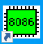

Step-2
The following window will appear. Click on “new”.
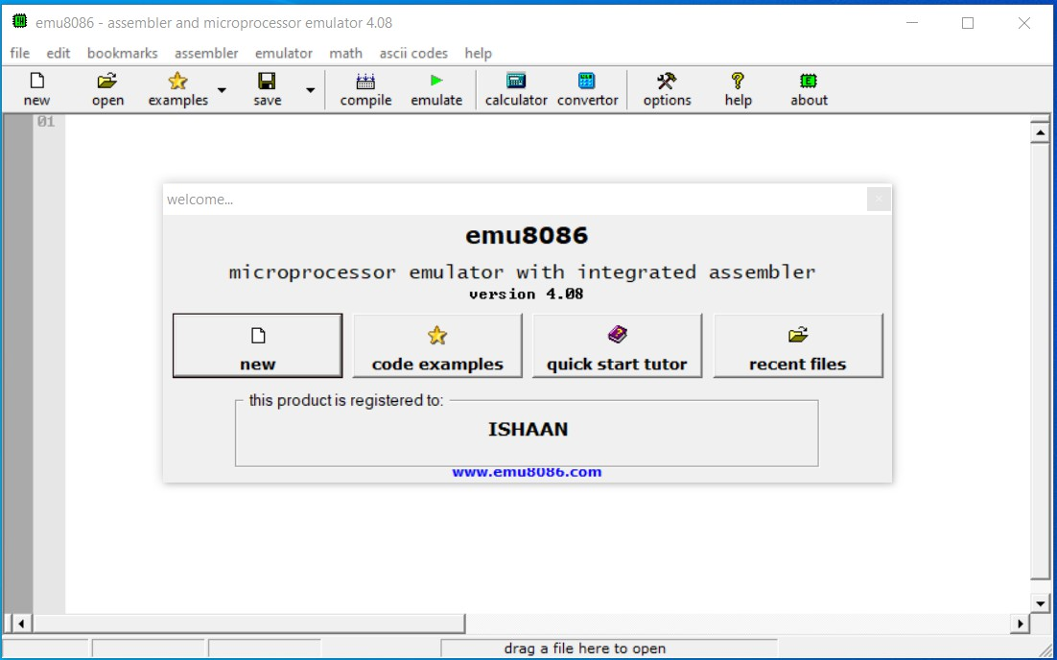

Step-3
Click on the empty workspace and press “OK”.
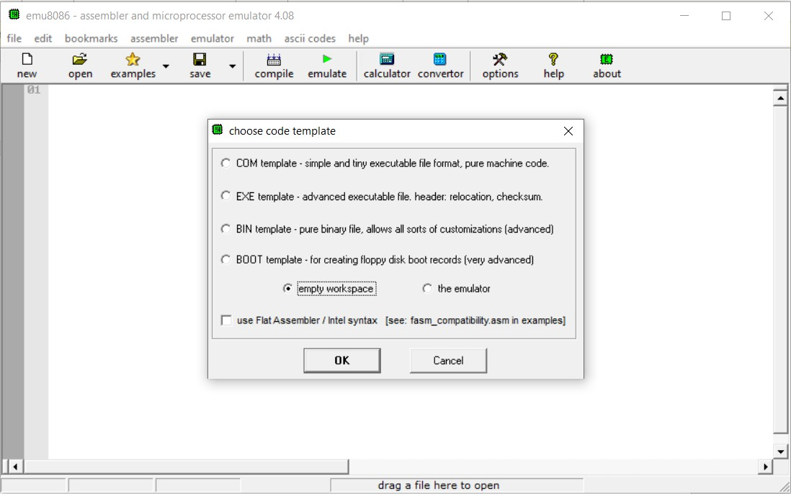

Step-4
Type the code given above and click on “emulate”.
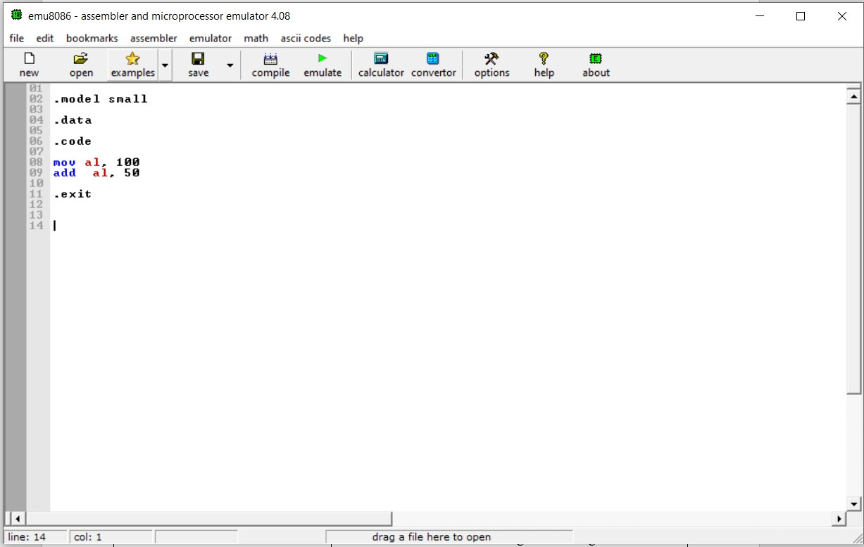

Step-5
Click on “flags” from the view menu OR click on the button “flags” at the bottom.
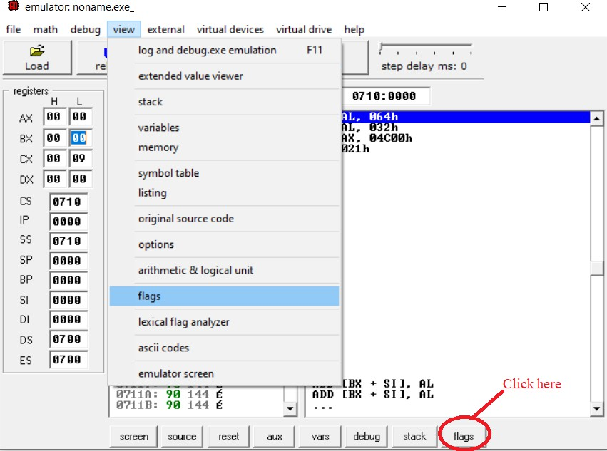

Step-6
Keep clicking on “Single step” to execute program instructions one by one. Stop clicking “Single step” just after the “Add al, 50” instruction to observe various flags.
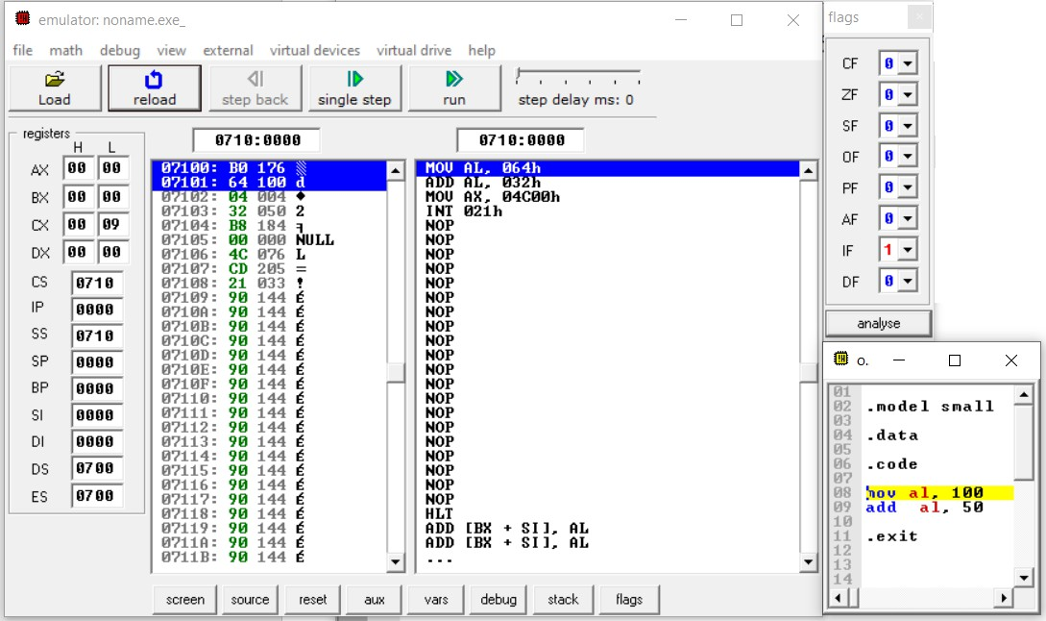

Step-7
The add al, 50 instruction sets the SF, OF, and PF.
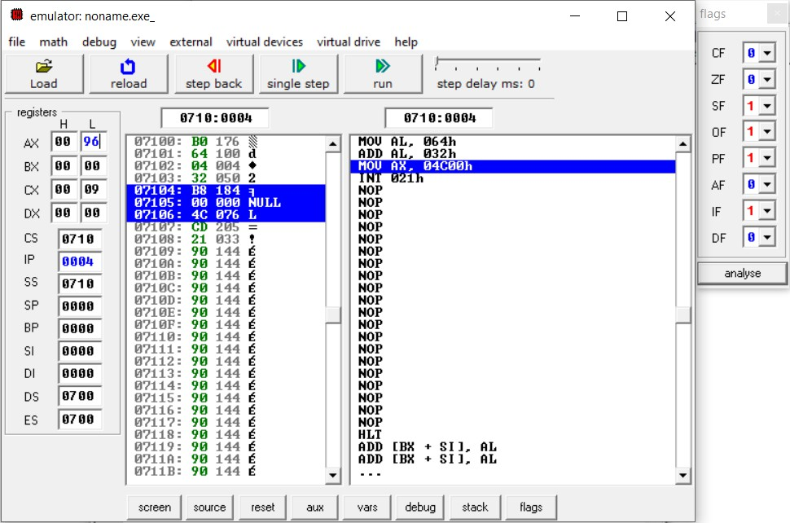

Observation:

- Why are the ZF and AF zero?

Lab-4 Exercise

Task-1
Write a program that stores the given two 32-bit numbers into the current data segment at offset: 0x1000 and 0x1008, respectively. The program then calculates the sum of these numbers and stores it at the offset: 0x1010.
Numbers: 0x1F540398, 0xC0A1F02E

Task-2
Write a program to implement the following equation. X = ~0xFF12 ^ {0xABFF & (0x2113 | 0x2340)}
~ | Invert all bits
^ | Bitwise XOR
& | Bitwise AND
| | Bitwise OR

Task-3
Perform any ALU operation that sets CF and OF at the same time.

